Title: Corporate Social Responsibility (CSR)
Last Updated: 09/10/2024
Commitment
Castle Print & Design Ltd is committed to conducting business in a responsible, ethical, and sustainable manner, while supporting the local community and minimising environmental impact.
Our Approach
Community Engagement

- Supporting local charities, sports organisations, and community initiatives

Workplace Standards

- Providing fair wages, safe working conditions, and equal opportunities for all employees

Ethical Business Practices

- Operating with honesty and integrity in all dealings with clients, suppliers, and partners

Environmental Responsibility

- Taking practical steps to reduce waste, use resources efficiently, and work with responsible suppliers where possible

Supply Chain Responsibility

- Working with suppliers who share our commitment to ethical, legal, and responsible business practices
Compliance & Review
We aim to operate in line with relevant UK legislation and will review this policy periodically to ensure it remains appropriate to the business.
Signed:
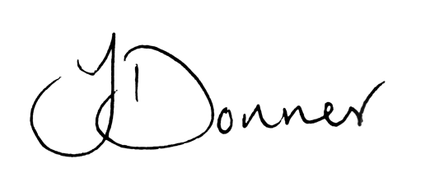
Joshua Donner
Director, Castle Print & Design Ltd

