Title: Environmental/Sustainability Policy
Last Updated: 09/10/2024
Statement
Castle Print & Design Ltd is committed to reducing environmental impact through responsible business practices and continuous improvement.
Key Practices
- Minimising material waste during production
- Using recyclable materials where possible
- Working with environmentally responsible suppliers
- Reducing unnecessary packaging
Energy Use
- Use of energy-efficient equipment and lighting where possible
Sustainable Sourcing
- Where possible, we aim to source materials from suppliers who demonstrate responsible environmental practices
Waste Management
- Waste materials are reduced, reused, or recycled wherever practical
Compliance
- We operate in accordance with applicable environmental legislation and regulations
Commitment
We aim to continuously improve our environmental performance as the business grows and will review this policy periodically.
Signed:
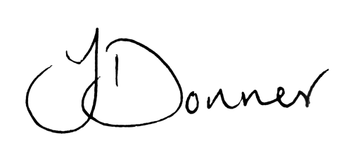
Joshua Donner
Director, Castle Print & Design Ltd

