Title: Modern Slavery Policy
Last Updated: 02/06/2024
Statement
Castle Print & Design Ltd has zero tolerance for modern slavery and human trafficking and is committed to preventing these practices within its business and supply chain.
Commitment
- Operates in compliance with UK Modern Slavery Act 2015
- Works only with reputable suppliers and partners
- Does not knowingly engage with organisations involved in forced labour, human trafficking, or child labour
Supply Chain
- Suppliers are selected based on reliability, quality, and ethical standards
- We expect suppliers to operate in line with applicable labour laws and ethical practices
- Any concerns regarding unethical practices are reviewed and addressed appropriately
Responsibility & Awareness
- Management is responsible for ensuring this policy is implemented
- Awareness of modern slavery risks is maintained through supplier selection and ongoing business practices
Reporting Concerns
Any concerns relating to modern slavery or unethical labour practices should be reported to management and will be investigated appropriately.

Signed:
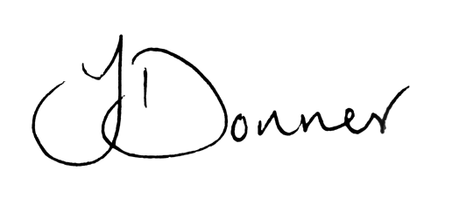
Joshua Donner
Director, Castle Print & Design Ltd

