Title: Quality Management Overview
Last Updated: 11/08/2025
Purpose: Castle Print & Design Ltd is committed to delivering high-quality design and print services through consistent processes, supplier control, and final verification.
Process Overview
- Client Brief & Approval
  - All work begins with a confirmed brief.
  - Visual proofs are provided where applicable.
  - Production only begins after client approval.
- Supplier & Material Control
  - Materials sourced from trusted suppliers.
  - Print outputs checked for consistency and specification.
- Production & Delivery
  - Jobs are produced in line with approved artwork and specifications.
  - Installation or delivery checked against order requirements.
- Final Inspection
  - Visual and functional checks carried out before supply.
  - Any issues resolved prior to handover.
Complaints & Corrective Action
- All complaints are reviewed directly by management.
- Root cause identified (design, material, production, installation).
- Corrective action taken to resolve and prevent recurrence.
Performance Review
- Quality performance reviewed periodically (informal management review).
- Feedback used to improve processes and supplier selection.
Continuous Improvement
- Ongoing improvements made based on client feedback and project outcomes.
Signed:
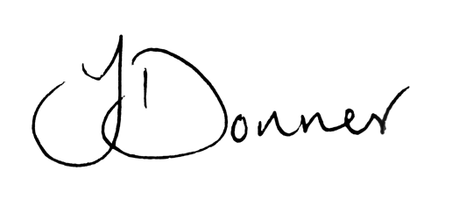
Joshua Donner
Director, Castle Print & Design Ltd

