Title: Supplier Code of Conduct
Last Updated: 04/08/2025
Expectations
Suppliers working with Castle Print & Design Ltd are expected to:
- Operate in full compliance with all applicable laws and regulations
- Conduct business ethically and with integrity at all times
- Provide consistent quality materials and services that meet agreed specifications
- Maintain safe and healthy working conditions for all employees
- Prohibit all forms of modern slavery, forced labour, and child labour
- Ensure fair wages and lawful working hours for employees
- Demonstrate environmental responsibility, including waste reduction and responsible sourcing where possible
- Maintain appropriate data protection and confidentiality standards where applicable
- Work collaboratively to resolve any quality or compliance issues promptly

Compliance
Castle Print & Design Ltd reserves the right to review supplier compliance with this Code and may reconsider working relationships where standards are not met.

Signed:
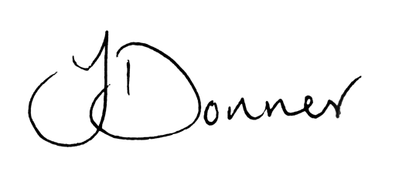
Joshua Donner
Director, Castle Print & Design Ltd

